FSANZ Branded Food Database Portal User Guide
Version 1
November 2022

Disclaimer
Food Standards Australia New Zealand has taken great care to ensure that the material provided in the FSANZ Branded Food Database Portal User Guide (this Guide) is as correct and accurate as possible. However, FSANZ makes no warranty with respect to the accuracy, currency, reliability or completeness of the material contained in this Guide or that that material, if used or relied on, will ensure accurate use of the FSANZ Branded Food Database Portal.
FSANZ makes material in this Guide available on the understanding that, before relying on the Guide and the material in it, you will exercise your own skill, care and judgment with respect to its use and you will carefully evaluate the accuracy, currency, completeness and relevance of the material for your purposes. FSANZ does not accept any legal liability or responsibility for any injury, loss or damage suffered by any person or persons arising out of or in connection with any use of, reliance on or interpretation of this Guide and the material contained in it.
You should also note that:
- There is no moderation of data fields in the FSANZ Branded Food Database Portal. The system will not check decimal places or significant figures and will allow numbers outside the realms of physical possibility. All data entered is the responsibility of the Brand Owner and should be checked for accuracy before it is submitted.
- The examples shown in this Guide do not represent real products and should not be used to inform or instruct the population of any data attributes.

Support
Any questions relating to the Australian Branded Food Database itself should be directed to the FSANZ Branded Food Database Team.
- Email: brandedfooddatabase@foodstandards.gov.au
If you have questions about the FSANZ Branded Food Database Portal and/or require further assistance with its use, please contact GS1 Australia via phone or email.
- Phone: 1300 227 263
- Email: fs.anz@gs1au.org

Copyright statement
© Food Standards Australia New Zealand
Food Standards Australia New Zealand (FSANZ) supports and encourages the dissemination and exchange of information. Information in this report is provided under a Creative Commons Attribution 3.0 Australia (CC BY 3.0) Licence, except for the Food Standards Australia New Zealand logo. An electronic version of this work is available on the FSANZ website at www.foodstandards.gov.au and, for New Zealand, www.foodstandards.govt.nz.

Attribution
You may copy, distribute, transmit and adapt the material in this publication by the CC BY 3.0 licence for commercial and non-commercial purposes, but you must attribute the work in the following manner:
© Food Standards Australia New Zealand.
This attribution must not, in any way, suggest that FSANZ endorses you or your use of the work. For more information email mailto:minformation@foodstandards.gov.au.
Contents
Disclaimer 2
Support 2
Background 4
Submitting your product data to FSANZ – Overview 4
Login to the FSANZ Portal 6
Products list 6
Creating New Product(s) – via online User Interface 7
Product Details 8
Packaging Markings 9
Ingredients & Diet 9
Nutrition 10
Images 12
Submit Product Data to FSANZ 13
Create New Product(s) – via FSANZ Data Template 14
FSANZ Data Template 14
FSANZ Template Instructions 14
FSANZ Product Data Template 15
Upload your FSANZ Product Data 15
Failed Template Loads 16
Submitting validated data 16
Update Product Data or Delete a Product 17
Update Product Data 17
Delete a Product 17

Background
FSANZ has developed the Australian Branded Food Database to provide a centralised, trusted and comprehensive source of brand-specific information for food products sold in Australia to:
a) inform FSANZ’s standards development work; and
b) support the development and monitoring of Australian Government public health policy and nutrition initiatives.
The purpose of this Guide is to assist food and beverage brand owners who are contributing data to the Australian Branded Food Database, with the use of the web based FSANZ Branded Food Database Portal (the FSANZ Portal). This Guide outlines the process for entering and submitting branded product data to FSANZ via the FSANZ Portal.

Submitting your product data to FSANZ – Overview
The FSANZ Portal provides a simple mechanism for submitting your product(s) data to FSANZ. This Guide explains how to log in to the FSANZ Portal, add data for your product(s) and submit your product(s) to FSANZ.
The following information is either required, or can be provided for each product you contribute to the Australian Branded Food Database.
Data Attribute Name | Requirement | Additional information
Trade Item Description | Derived Value | Manual entry not required - Field is derived from other data
Brand Name | Mandatory | Required for all products
Type of Product | Mandatory | Required for all products
Variant Description | Mandatory | Required for all products
Net Content | Mandatory | Required for all products
Net Content UOM | Mandatory | Required for all products
GTIN | Mandatory | Required for all products
Start Availability Date | Mandatory | Required for all products
End Availability Date | Optional | Required when product is removed from market
Brand Owner Name | Mandatory | Required for all products
Brand Owner Address | Optional | Provided at discretion of brand owner
Country of Origin | Optional | Provided at discretion of brand owner
GPC (Brick) Category | Mandatory | Required for all products
Health Star Rating Category | Mandatory | Required for all products
Does Product Label have a Health Star Rating | Mandatory | Required for all products
Health Star Rating | Conditionally Mandatory | Required if product has a Health Star Rating
Servings per Pack | Conditionally Mandatory | Required if product has a Nutrition Information Panel (NIP)
Serving Size | Conditionally Mandatory | Required if product has a NIP
Serving Size UOM | Conditionally Mandatory | Required if product has a NIP
Form of Food | Conditionally Mandatory | Required if product has a NIP
Energy (kJ) | Conditionally Mandatory | Required if product has a NIP
Protein (g) | Conditionally Mandatory | Required if product has a NIP
Fat-Total (g) | Conditionally Mandatory | Required if product has a NIP
Fat-Saturated (g) | Conditionally Mandatory | Required if product has a NIP
Carbohydrate (g) | Conditionally Mandatory | Required if product has a NIP
Sugars - Total (g) | Conditionally Mandatory | Required if product has a NIP
Dietary Fibre - Total (g) | Conditionally Mandatory | Required if product has a NIP
Sodium (mg) | Conditionally Mandatory | Required if product has a NIP
Added Sugar (g) | Optional | Provided at discretion of brand owner
Additional Nutrients | Optional | Provided at discretion of brand owner
Percentage Fruits, Vegetables, Nuts & Legumes | Conditionally Mandatory | Not required for liquor products
Percentage Concentrated Fruits & Vegetables | Conditionally Mandatory | Not required for liquor products
Percentage Whole Grain | Optional | Provided at discretion of brand owner
Allergen Statement | Optional | Provided at discretion of brand owner
Labelling Claims | Optional | Provided at discretion of brand owner
Ingredient Statement | Mandatory | Required for all products
Percentage Alcohol by Volume | Optional | Provided at discretion of brand owner
Number of Standard Drinks | Optional | Provided at discretion of brand owner

Login to the FSANZ Portal
You can navigate to the FSANZ Portal via:
- the FSANZ Portal link found on the Australian Branded Food Database webpage on the FSANZ website - foodstandards.gov.au, or
- by entering the following web address into your web browser search bar - npcx.gs1au.org/fsanz
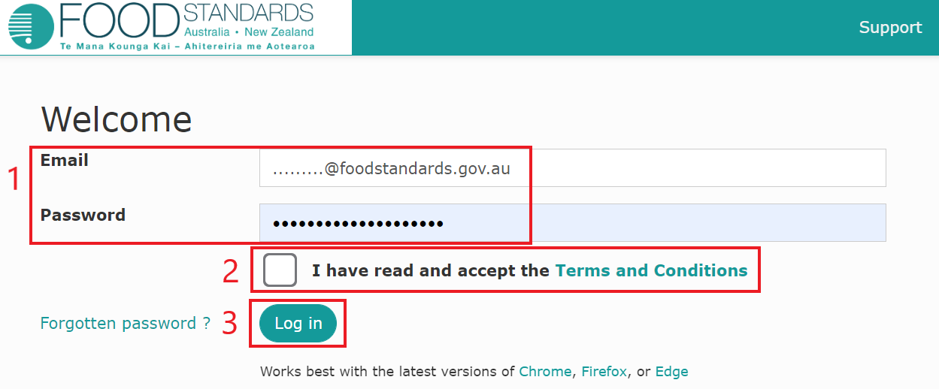
Once you have navigated to the FSANZ Portal you will find yourself on the Welcome screen where you can log in using the credentials - Email and Password - issued to you at sign up.
Enter your credentials (1), read and accept the Terms and Conditions (2) and click Log in (3).
N.B. If you need to reset your password, you can initiate the creation of a new password via the ‘Forgotten password’ hyperlink next to the Log in button on the Welcome screen.
Special characters ‘<’ and ‘>’ are not compatible with the password format and should not be used.

Products list
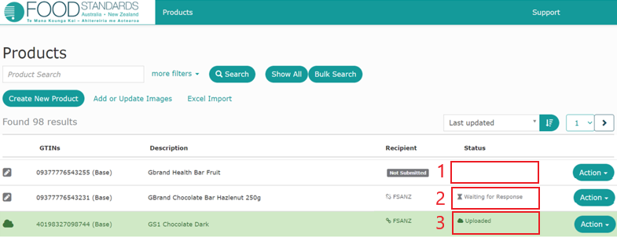
Once successfully logged into the FSANZ Portal you will land on the Products screen. This screen lists all products that have already been entered into the FSANZ Portal; and allows you to create new product entries and update existing product entries.
Products:
- not yet complete and/or submitted to FSANZ will have NULL status (1)
- submitted to but not yet received will have a status of “Waiting for Response” (2)
- successfully submitted will have a status of “Uploaded” (3).

Creating New Product(s) – via online User Interface
A. 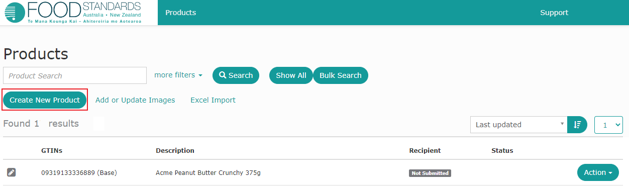
B. 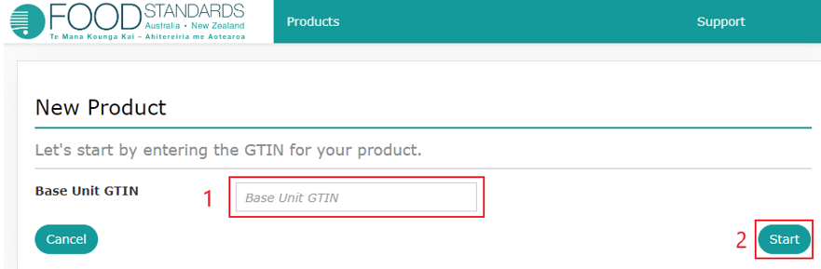
C. 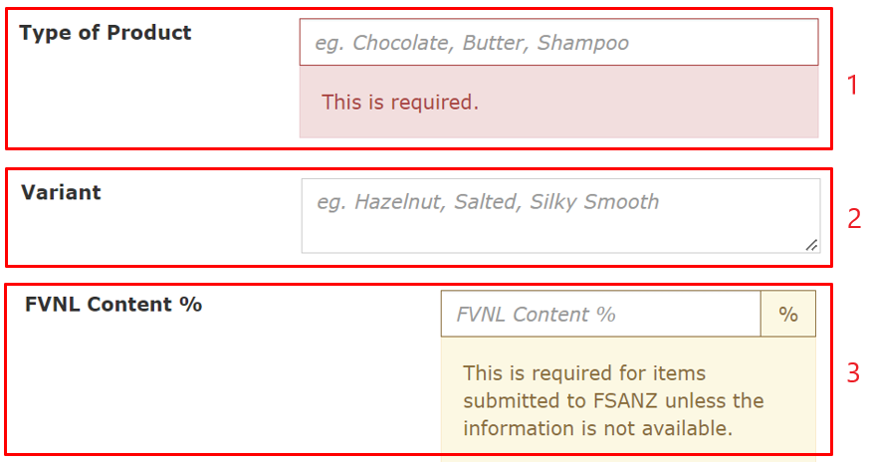
Click on Create New Product on the Products screen (A).
Enter the GTIN (B1) (Global Trade Item Number i.e. barcode number) and click Start (B2).
Once a product record has been created, details need to be entered against each of four separate screens: Product Details; Packaging Materials; Ingredients & Diet; and Nutrition. Each screen will contain both mandatory and optional data fields (C) which are flagged as follows throughout this guide:
- Mandatory fields (C1) are flagged as ‘(M)’ throughout this guide.
- Optional fields (C2) are flagged as ‘(O)’ throughout this guide.
- Conditionally mandatory fields (C3) are flagged as (M*) throughout this guide.
In most cases the requirement to provide conditionally mandatory data will depend on your product type, e.g. if product type requires you to display a nutrition information panel you will be required to provide nutrition information.

Product Details
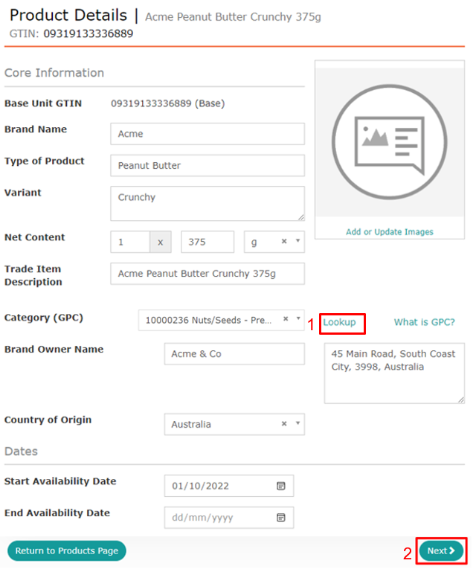
On the Product Details enter the following information:
- Brand Name (M), e.g. Acme
- Type of Product (M), e.g. Peanut Butter
- Variant (O), e.g. Crunchy
- Net Content (M), e.g. 375 g
- Category (GPC) (M), e.g. 10000236-Nuts/Seeds – Prepared/Processed (Out of Shell)
- Brand Owner Name (M), e.g. Acme & Co
- Brand Owner Address (O), e.g.5 Main Road, South Coast City, 3998, Australia
- Start Availability Date (M)
- End Availability Date (O)
Enter data for all mandatory, and relevant optional, data fields and click Next (2) to save.
N.B. The Category (GPC) field is derived from the Global Product Classification (GPC) list. The GPC classifies products by grouping them into categories based on their essential properties as well as their relationships to other products. A Category (GPC) look up is available if you do not know the applicable GPC code or descriptor. To search for a relevant Category (GPC), click on the ‘Lookup’ (1) hyperlink. You will be directed to the GS1 GPC Lookup where you can search for the relevant descriptor by entering a term that best describes the product, e.g. for the above product type ‘peanut’.
Trade Item Description will be auto-populated based on information you provide. The system prohibits manual entry of information for this field.

Packaging Markings
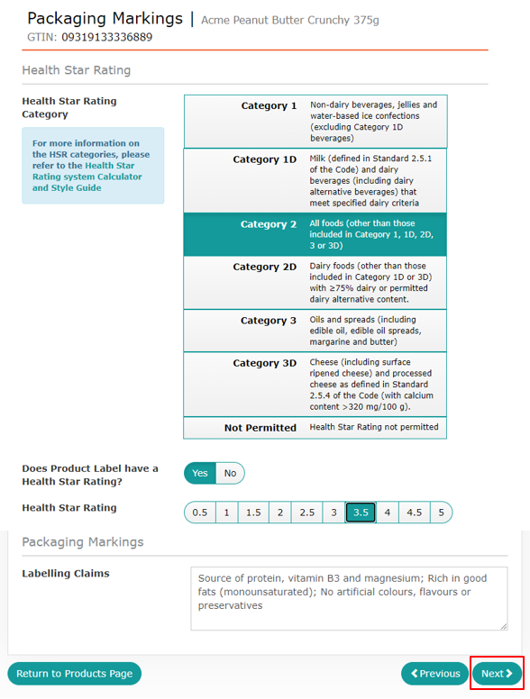
On the Packaging Markings screen enter the following information:
- Health Star Rating Category (M)
- whether your product label has a Health Star Rating (M)
- (if your product label has a Health Star Rating) the numerical Health Star Rating (M*)
- Labelling Claims (O), e.g. Source of protein.
Enter data for all mandatory, and relevant optional, data fields and click Next to save.
N.B. The Health Star Rating categorisation system is being applied to all products within the Branded Food Database. You must select the relevant category for your product regardless of whether the product label has a Health Star Rating. For more information on Health Star Rating Categories refer to Appendix 1.
Displaying a Health Star Rating on shelf ready boxes, shelf tickets and/or brand and retail websites does not constitute the display of a Health Star Rating. If you do not display a Health Star Rating on a physical consumer unit label, you should select ‘No’ when asked ‘Does Product Label have a Health Star Rating?’.

Ingredients & Diet
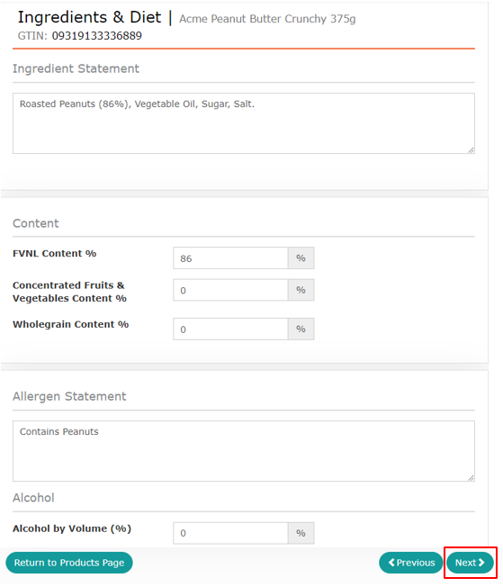
On the Ingredients & Diet screen enter the following information:
- Ingredient statement (M), e.g. Roasted Peanuts (86%), Vegetable Oil, Sugar, Salt.
- FVNL Content % (M*), e.g. 86%
- Concentrated Fruits & Vegetables Content % (M*), e.g. 0%\
- Wholegrain Content (O), e.g. 0%,
- Allergen Statement (O), e.g. Contains Peanuts, and
- Alcohol by Volume (%) (O), e.g. 0% should be entered if applicable.
Enter data for all mandatory, and relevant optional, data fields and click Next to save.
N.B. For information on how to determine FVNL Content and Concentrated Fruits & Vegetables Content refer to Appendix 2.
Concentrated Fruits and Vegetables Content should not be included as a component of FVNL Content – refer Appendix 2 for further detail.

Nutrition
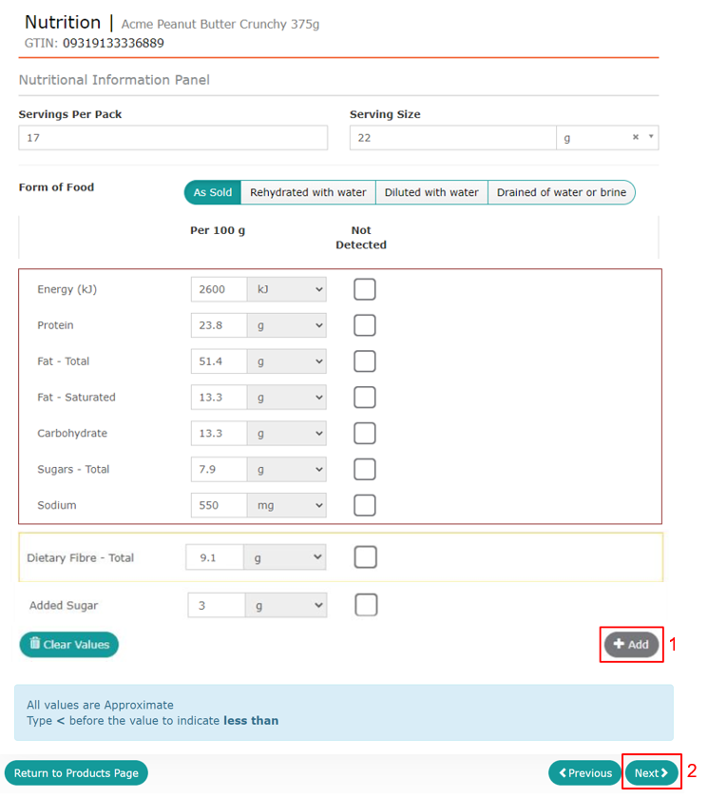
Nutrition information should be provided if your product is required by the Australia New Zealand Food Standards Code to carry a Nutrition Information Panel (NIP).
If your product is exempt from carrying a NIP, do not enter any data on this screen. Please click Next and proceed to the Images screen.
If your product is required to carry a NIP, on the Nutrition screen enter the following information:
- Servings Per Pack (M*), e.g. 17
- Serving Size (including measure) (M*), e.g. 22 grams
- Form of Food (M*), e.g. As sold
- Energy (kJ) (M*), e.g. 2600
- Protein (g) (M*), e.g. 23.8
- Fat – Total (g) (M*), e.g. 51.4
- Fat – Saturated (g) (M*), e.g. 13.3
- Carbohydrate (g) (M*), e.g. 13.3
- Sugars – Total (g) (M*), e.g. 7.9
- Sodium (mg) (M*), e.g. 550
- Dietary Fibre – Total (g) (M*), e.g. 9.1
- Added Sugar (g) (O), e.g. 3
Additional nutrients listed in the NIP on the label should be added using the + Add (1) button.
Enter data for all mandatory, and relevant optional, data fields and click Next (2) to save.

Images
The functionality to upload product images via the FSANZ Portal is still being developed.
Click Next to proceed to the submission screen.

Submit Product Data to FSANZ
- 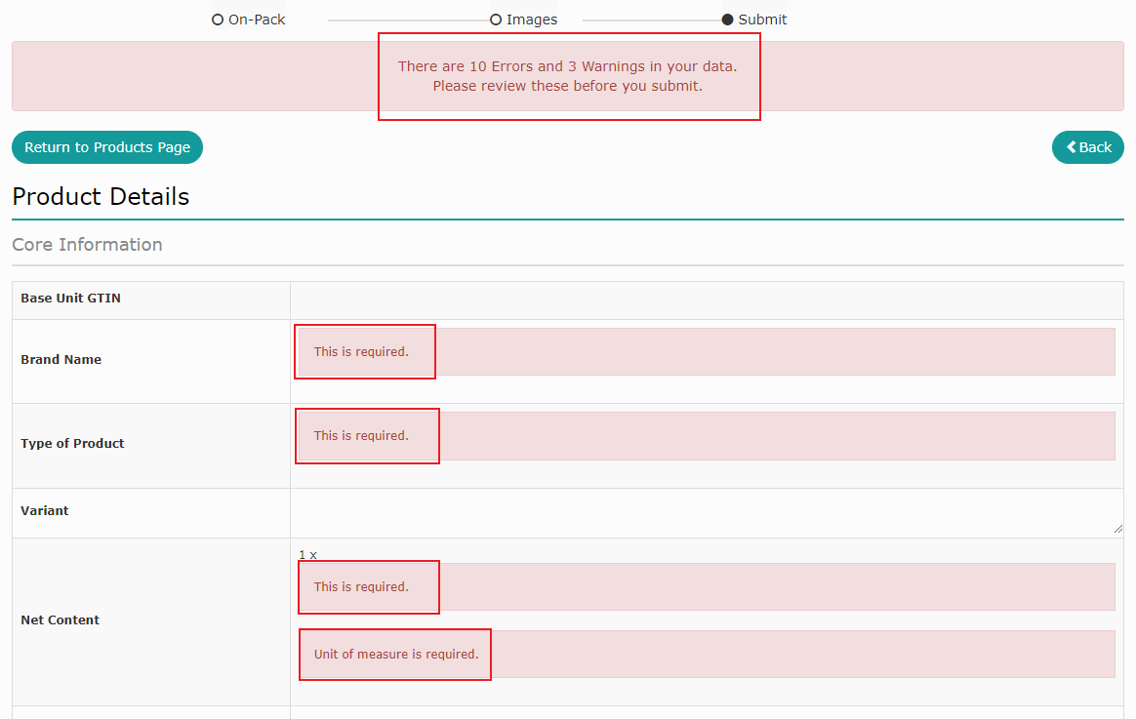
- 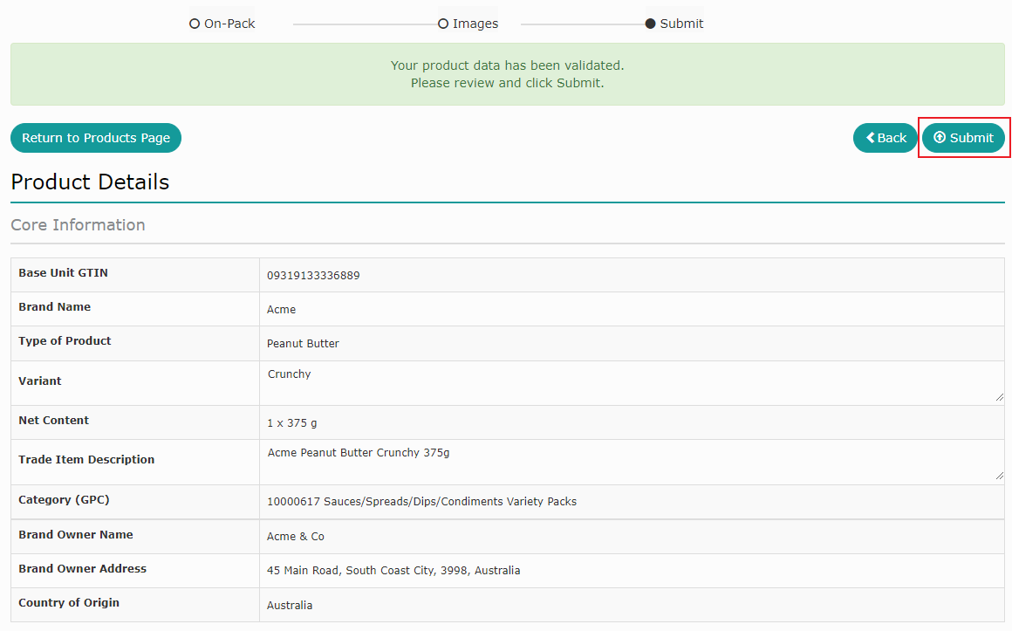
- 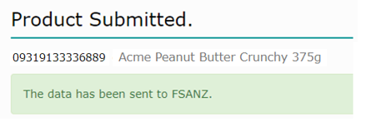
The submission screen will display all data for each product on one scrollable page.
If there is missing data at this point your screen will highlight errors that need to be corrected before the product can be submitted (A).
If all data has been provided, a message stating that ‘Your product has been validated’ will be displayed (B). Review your data and once you are happy click Submit to send your data to FSANZ.
If your product has been submitted successfully a confirmation screen will display (C).

Create New Product(s) – via FSANZ Data Template
- 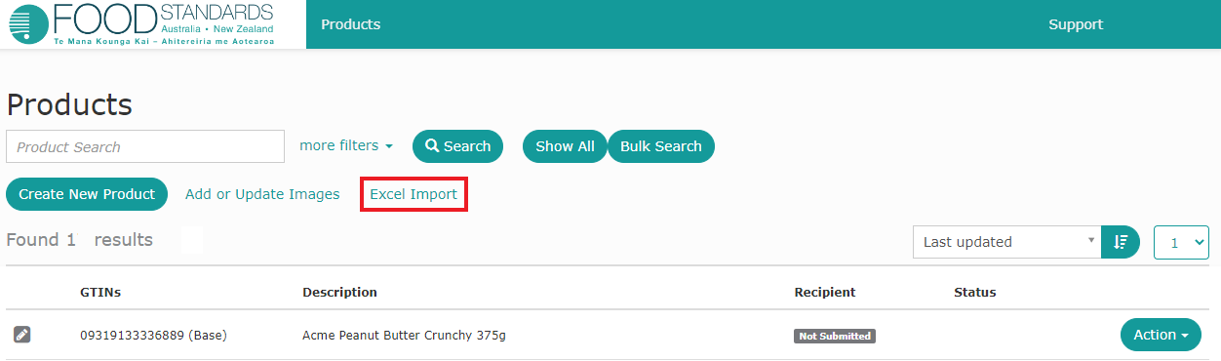

- 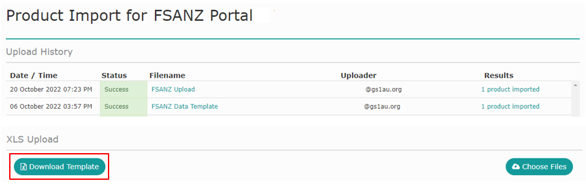
A fast way to load multiple new products is via Excel Import. Click the ‘Excel Import’ hyperlink on the Products screen (A). From here you will be taken to the Product Import screen, showing upload history (B).
Click on Download Template . This is the file you will need to populate with product data and upload to the FSANZ Portal.

FSANZ Data Template
The FSANZ Data Template is intended to provide Brand Owners with a simple method for providing product data to FSANZ. The first task is to enter information about your products into the FSANZ Data Template. You can then upload the document to the FSANZ Portal, validate your data and submit to FSANZ.
The template has two worksheet tabs: FSANZ Template Instructions and FSANZ Product Data Template.

FSANZ Template Instructions
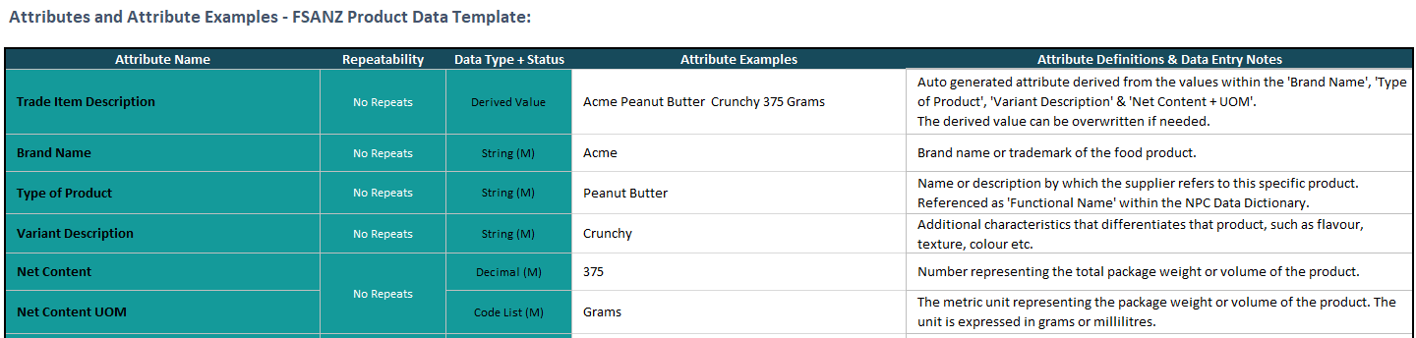
This worksheet explains the structure of the FSANZ Data Template, provides a definition for the attributes listed in the header row, and importantly details how to populate each data attribute. Below is a sample excerpt from this worksheet.

FSANZ Product Data Template
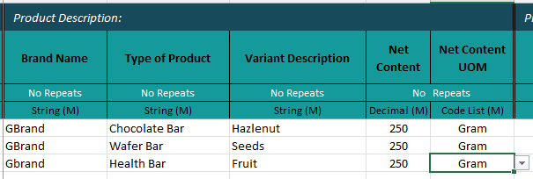
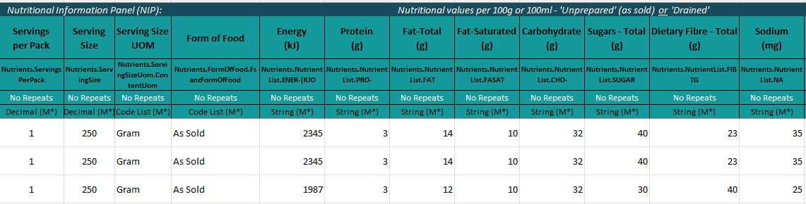
To enter your products populate a row for each new product you want to load, ensuring you populate all Mandatory (M) fields. Refer back to the FSANZ Template Instructions tab for definitions and examples to guide you.

Upload your FSANZ Product Data
- 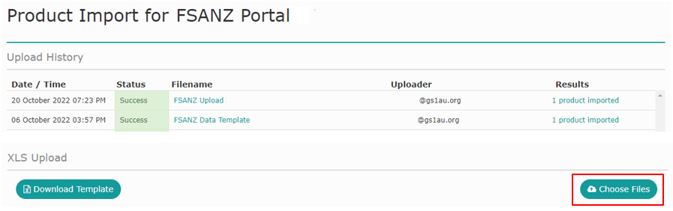
- 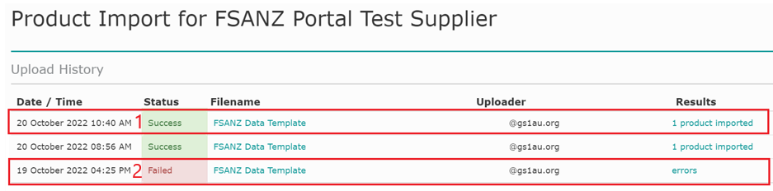
Click on the ‘Excel Import’ hyperlink on the Products screen (A). From here you will be taken to the Product Import screen (B). Click on Choose Files (B), or drag and drop your document on the ‘Drop XLS file here to upload’ image on the Product Import screen (C).
If your upload has been successful the ‘Status’ under the upload history will display ‘Success’ (D1); if it has not been successful it will display ‘Failed’ (D2).

Failed Template Loads
- 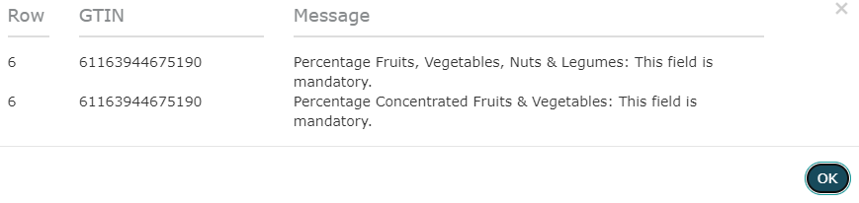
If your Template has failed to load, click on the ‘errors’ hyperlink to identify the issue/s (A).
Once you have clicked on the ‘errors’ hyperlink, an error log will appear (B). The error log will identify the row/s in the template that need attention and the resolution required. Resolve the errors identified and re-load your product data following the upload instructions above.
N.B. Any single error in a Template upload will cause the entire upload to fail. Existing products with complete data need to be retained in the re-load.

Submitting validated data
A. 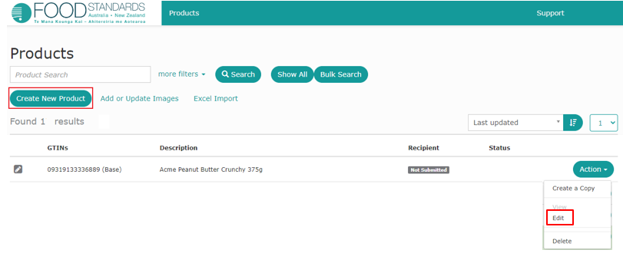
B. 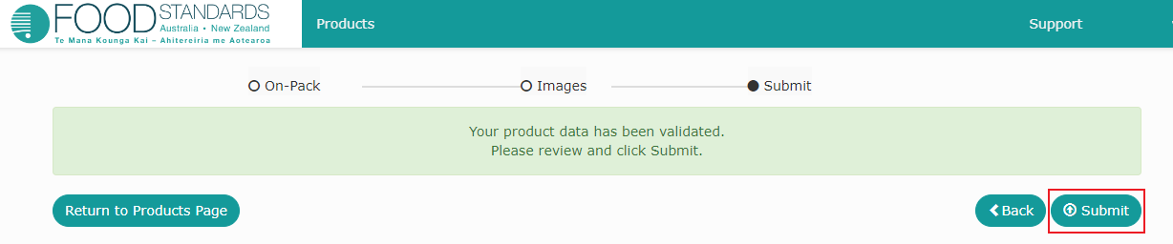
Once your upload has been successful, return to the Products screen. Each product uploaded via the Excel Import must now be submitted at the User Interface. For each loaded item, choose Edit on the product Action menu (A) and you will be directed to the Submission screen (B). Click on Submit to send the validated Product Data to FSANZ.
N.B. If you wish to make changes or additions to a product that has been uploaded but not yet submitted, you can do so by navigating through the relevant screens and entering data before submitting the product.

Update Product Data or Delete a Product
- 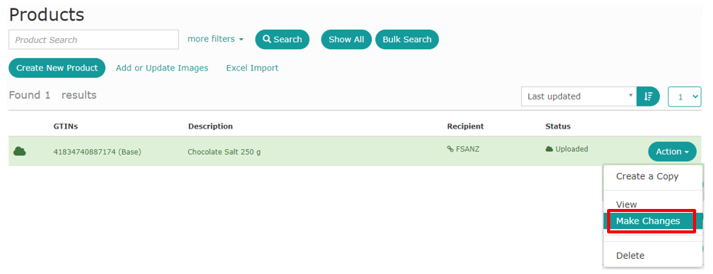
- 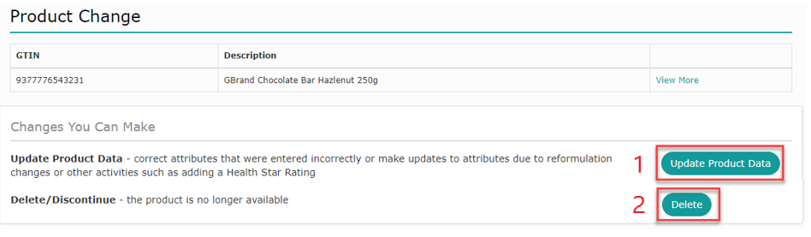
If your product is removed from the market (end dated) or the data changes, for example through reformulation, you can update the product record via the Products screen.
To end date or make changes to a product select Make Changes on the product’s Action menu (A), from here you will be taken to the Product Change screen (B).
On the Product Change screen Click on Update Product Data (B1) or Delete (B2) and proceed as instructed below.

Update Product Data
Clicking Update Product Data will simply take you into the Product Details screen from where you can navigate to where the changes need to be made.
Make your changes, validate and submit your product data per the instructions for creating and submitting a product above.

Delete a Product
- 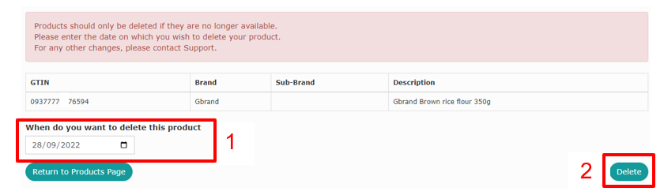
- 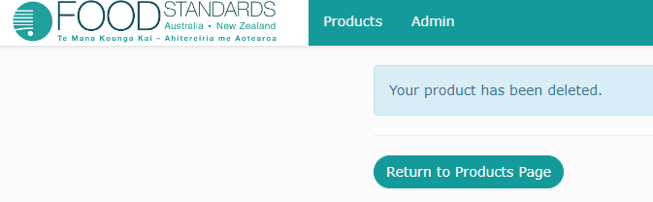
Clicking Delete as instructed above will take you to the delete screen (A). Enter the date when the product was removed from market (A1) and click Delete (A2).
Confirmation will display when your product has been successfully deleted (B).
N.B. The delete function should only be used for products that have been removed (deleted) from market. If you accidentally create a product and want to delete the record, please contact GS1 Australia using the contact details provided at the front of this Guide.

Appendix 1

Health Star Rating Categories
The six categories of foods in the HSR Calculator are:
Category 1 Non-dairy beverages, jellies and water-based ice confections (excluding Category 1D beverages)
Category 1D Milk (defined in Standard 2.5.1 of the Code) and dairy beverages (including dairy alternative beverages) that meet specified dairy criteria
Category 2 All foods (other than those included in Category 1, 1D, 2D, 3 or 3D)
Category 2D Dairy foods (other than those included in Category 1D or 3D) with ≥75% dairy or permitted dairy alternative content.
Category 3 Oils and spreads, defined as follows
  - edible oil as defined in Standard 2.4.1 of the Code
  - edible oil spreads as defined in Standard 2.4.2 of the Code
  - margarine as defined in Standard 2.4.2 of the Code
  - butter as defined in Standard 2.5.5 of the Code
Category 3D Cheese (including surface ripened cheese) and processed cheese as defined in Standard 2.5.4 of the Code (with calcium content >320 mg/100 g).
Dairy (D) foods
A dairy food is defined as a milk, dairy beverage, cheese or yoghurt produced from milking animals (for example from cow, goat or buffalo), including fermented milk products, that meets the relevant calcium criterion for dairy foods outlined below.
Standard 2.5.1 of the Code defines compositional requirements for the minimum milk fat and protein content of cow’s milk. Beverages made from milk that do not meet these compositional criteria are termed ‘dairy beverages’ in this guide.
For the purposes of Health Star Rating categorisation, milk and dairy beverage alternatives derived from legumes, cereals, nuts or seeds may be considered to belong to Category 1D providing they meet the relevant calcium criterion and protein requirements outlined below.
Dairy food alternatives derived from legumes may be considered in the dairy food categories (2D or 3D), providing they meet the relevant calcium criterion and protein requirements for dairy foods outlined below.
The criteria below are used to determine the HSR category.
Category 1D includes:
- milk and dairy beverages with ≥ 80 mg calcium/serve (this equates to sufficient calcium to meet the requirements for a ‘source of calcium’ claim under Standard 1.2.7 of the Code. A reference serve of 200 mL is given in Schedule 17).
- milk and dairy beverage alternatives derived from legumes that contain no less than 3% m/m protein derived from legumes and have ≥100 mg calcium per 100 mL .
- milk and dairy beverage alternatives derived from cereals, nuts, seeds, or a combination of those ingredients that contain no less than 0.3% m/m protein derived from cereals, nuts, seeds, or a combination of those ingredients, and have ≥100 mg calcium per 100 mL.
- milk, dairy beverages, and milk and dairy beverage alternatives, must contain ≥75% dairy or permitted dairy-alternative ingredients (refer example below).
Category 2D includes:
- all dairy foods not included in HSR Categories 1D or 3D, including cheeses with a calcium level ≤320 mg/100 g (e.g. ricotta, cottage cheese, cream cheese), yoghurt, fermented milk products, cream, dairy desserts and other chilled (but not frozen) dairy products.
- cheese alternatives derived from legumes that contain no less than 15% m/m protein derived from legumes and have a calcium level of ≤320 mg/100 g.
- yoghurt dairy dessert alternatives derived from legumes that contain no less than 3.1% m/m protein derived from legumes.
- dairy foods and alternatives must contain ≥75% dairy or permitted dairy-alternative ingredients (refer example below). This category does not include ice cream or alternatives derived from cereals, nuts or seeds. These products fall in Category 2.
Category 3D includes:
- cheese (including surface ripened cheeses) and processed cheese, as defined in Standard 2.5.4 of the Code, with a calcium content > 320 mg/100 g. Must consist of >75% dairy ingredients.
- cheese alternatives derived from legumes that contain no less than 15% m/m protein derived from legumes and have a calcium content > 320 mg/100 g and contain >75% permitted dairy-alternative ingredients (refer example below).
Dairy-alternative ingredients
- For the purposes of Categories 1D, 2D and 3D ‘permitted dairy-alternative ingredients’ are those that are permitted by the Code and would otherwise be expected to be found as an ingredient in a ‘dairy-alternative’ product.

E.g. 1
A soy milk could reasonably be expected to be contain the following ingredients - Water, Soy Protein, Maltodextrin, Vegetable Oil, Sugar, Acidity Regulators, Emulsifiers, Thickeners, Stabilisers, Natural Flavours, Calcium, Vitamins.
A chocolate flavoured soy milk with any of the above ingredients and 3.5% cocoa would be considered a dairy alternative beverage that contained 96.5% ‘permitted dairy-alternative ingredients’ and 3.5% ‘other ingredients’. The beverage contains ≥75% permitted dairy-alternative ingredients and would therefore fall in Category 1D.
E.g. 2
A natural soy yogurt could reasonably be expected to be contain the following ingredients - Water, Soybeans, Canola Oil, Sugar, Thickeners, Preservatives, Flavour, Yoghurt Cultures.

Appendix 2

Fruit, Vegetable, Nut and Legume Content
Fruit, vegetable, nut and legume (FVNL) content comprises:
- all fruits, vegetables, nuts and legumes including coconut, spices, herbs, fungi, seeds and algae,
- FVNL that are fresh, cooked, frozen, canned, pickled or preserved,
- FVNL that have been peeled, diced or cut (or otherwise reduced in size), puréed or dried,
- fruit juice or vegetable juice as standardised in Standard 2.6.1 of the Australia New Zealand Food Standards Code including concentrated juices and purées,
- coconut flesh (which is to be scored as a nut), whether juiced, dried or desiccated, but not processed coconut products such as coconut milk, coconut cream or coconut oil,
- the water in the centre of the coconut.
Nuts and legumes are specifically excluded from the definition of fruit and vegetables and are considered (non-concentrated) FVNL in all forms, i.e. fresh, dried, roasted etc.
Potato crisps and similar low moisture vegetable products are taken to be non-concentrated.
FVNL does not include a constituent, extract or isolate of a food e.g. peanut oil, fruit pectin and de-ionised juice.
Concentrated Fruits and Vegetable Content should not be included as a component of FVNL content.
Example:
54% of the ingredients in Product A are fruits, vegetables, nuts and/or legumes.
- 5% is apple juice
- 17% is concentrated apple puree
- 20% is dates, and
- 12% is roasted cashews
The 17% concentrated apple puree is considered Concentrated Fruits and Vegetable Content, thus the value entered for Concentrated Fruits and Vegetable Content is 17%.
The remaining fruit, vegetable, nut and legume ingredients are not concentrated, thus the value entered for FVNL Content is 37%.
- Data entered is
FVNL Content %: 37%
Concentrated Fruits & Vegetables Content %: 17%
- Data entered is not
FVNL Content %: 54
Concentrated Fruits & Vegetables Content %: 17%

The requirement for dairy beverage alternatives to contain a ≥100mg calcium per 100mL aligns with the recommendation of the Australian Dietary Guidelines to select milk and dairy beverages alternatives with at least 100mg of added calcium per 100ml.
The types of products permitted to be considered ‘dairy alternatives’ align with those that are considered analogues and are permitted to be fortified with calcium in accordance with Schedule 17 of the Code, e.g. The Code does not provide for fortification of analogues of cheese derived from nuts and consequently these types of products are treated as a Category 2 – food and not a Category 2D - dairy food.

